DEPARTMENT OF INFORMATION TECHNOLOGY

Course Name and Code: Data Structures Lab (ITL302)
Semester: III (SYIT)
Academic Year: 2023-24 (Odd Semester)
Name: parnika gangrade

Experiment No. 06

Aim: implementation of binary tree and its traversal of real world application.

Objectives:
1. To learn fundamental and implementation of binary tree
2. to devlop an ability to keep design and analyze algorithm using tree data structure.

Theory:
A binary tree is a data structure in which each node has at most two children, referred to as the left child and the right child. It is widely used in computer science for organizing and storing data in a hierarchical manner, making tasks like searching, inserting, and deleting more efficient.

Program:

#include <stdio.h>
#include <stdlib.h>

struct node {
int data;
struct node *left;
struct node *right;
};
struct node *tree = NULL;

struct node *insertElement(struct node *, int);
void inorderTraversal(struct node *);
void preorderTraversal(struct node *);
void postorderTraversal(struct node *);
void create_tree(struct node **);

int main() {
printf("Welcome to implementation of binary tree traversals\n");
int choice, val;

do {
printf("\nOperations available:");
printf("\n 1. Insert a node");
printf("\n 2. Display Inorder traversal");
printf("\n 3. Display Preorder traversal");
printf("\n 4. Display Postorder traversal");
printf("\n 5. Exit\n");
printf("Please enter your choice: ");
scanf("%d", &choice);

switch (choice) {
case 1:
printf("\nEnter the value of the new node: ");
scanf("%d", &val);
tree = insertElement(tree, val);
break;
case 2:
printf("\nThe elements of the tree in Inorder are: \n");
inorderTraversal(tree);
break;
case 3:
printf("\nThe elements of the tree in Preorder are: \n");
preorderTraversal(tree);
break;
case 4:
printf("\nThe elements of the tree in Postorder are: \n");
postorderTraversal(tree);
break;
case 5:
printf("Exiting the program...\n");
break;
default:
printf("Invalid choice! Please try again.\n");
}
} while (choice != 5);

return 0;
}

void create_tree(struct node **tree) {
*tree = NULL;
}

struct node *insertElement(struct node *tree, int val) {
struct node *ptr, *nodeptr, *parentptr;
ptr = (struct node *)malloc(sizeof(struct node));
ptr->data = val;
ptr->left = NULL;
ptr->right = NULL;

if (tree == NULL) {
tree = ptr;
} else {
parentptr = NULL;
nodeptr = tree;

while (nodeptr != NULL) {
parentptr = nodeptr;
if (val < nodeptr->data)
nodeptr = nodeptr->left;
else
nodeptr = nodeptr->right;
}

if (val < parentptr->data)
parentptr->left = ptr;
else
parentptr->right = ptr;
}

return tree;
}

void inorderTraversal(struct node *tree) {
if (tree != NULL) {
inorderTraversal(tree->left);
printf("%d ", tree->data);
inorderTraversal(tree->right);
}
}

void preorderTraversal(struct node *tree) {
if (tree != NULL) {
printf("%d ", tree->data);
preorderTraversal(tree->left);
preorderTraversal(tree->right);
}
}
void postorderTraversal(struct node *tree) {
if (tree != NULL) {
postorderTraversal(tree->left);
postorderTraversal(tree->right);
printf("%d ", tree->data);
}
}
void postorderTraversal(struct node *tree) {
if (tree != NULL) {
postorderTraversal(tree->left);
postorderTraversal(tree->right);
printf("%d ", tree->data);
}
}

program code screenshot:

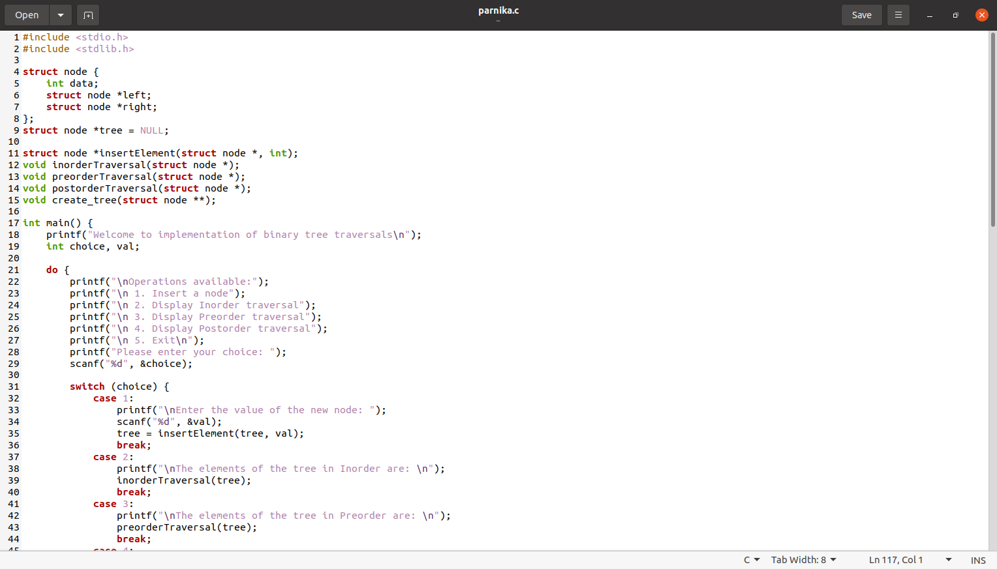
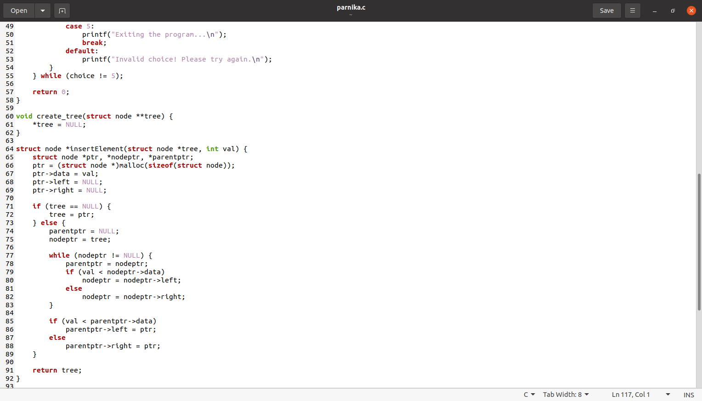

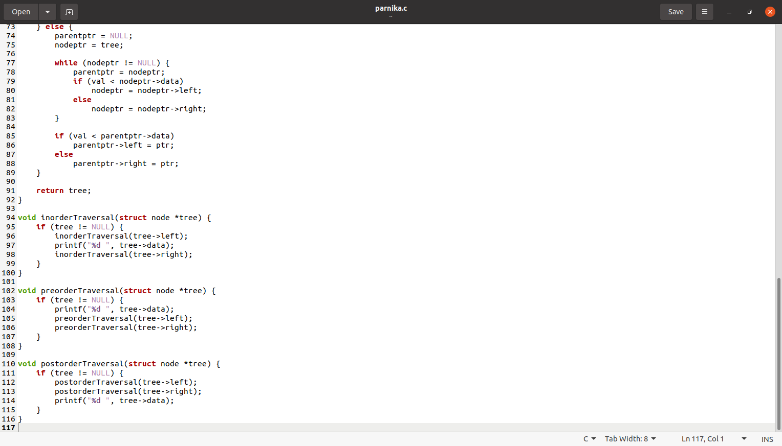

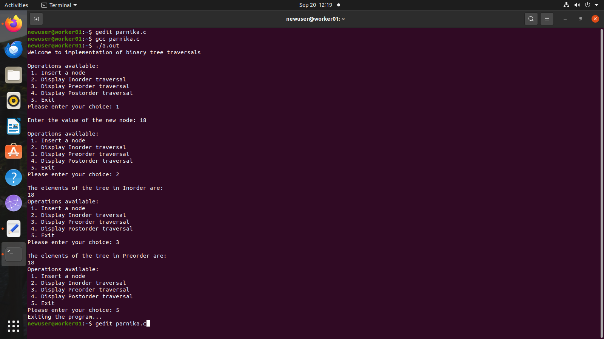

Output:

